Customer Segmentation Using K-Means Clustering

Introduction
Customer segmentation is a critical practice for businesses aiming to understand their customer base and tailor services or marketing efforts effectively. By grouping customers based on shared characteristics, businesses can:
- Improve marketing strategies through personalization.
- Enhance customer satisfaction by addressing specific needs.
- Optimize resources for better operational efficiency.
This report focuses on using the K-Means clustering algorithm to group customers based on their spending habits and demographics.
Why K-Means Clustering?
- Efficiency: K-Means is computationally fast for small to medium-sized datasets.
- Interpretability: It produces distinct and interpretable clusters, making it ideal for business applications.
- Applicability: It works well on numerical data and is widely used in various industries.

Objective
This report aims to guide users through:
- Exploring the dataset to understand its structure and identify potential groupings.
- Preprocessing the data to handle missing values, normalize features, and encode categorical variables.
- Implementing the K-Means algorithm to segment customers into clusters.
- Visualizing and evaluating the quality of these clusters.

Dataset Overview
Dataset Source
The dataset used in this report is the Mall Customers Dataset, available on Kaggle. It contains demographic and spending data for mall customers.
Dataset Features
Feature Name | Description | Type
CustomerID | Unique identifier for each customer | Categorical
Gender | Gender of the customer | Categorical
Age | Age of the customer | Numeric
Annual Income | Annual income of the customer (k$) | Numeric
Spending Score | Spending score assigned to the customer (0-100) | Numeric
Target Variable
This dataset does not have a target variable, as clustering is an unsupervised learning task.
Applications of This Dataset
- Customer Insights: Understand purchasing behavior patterns.
- Marketing Strategy: Create personalized campaigns.
- Resource Allocation: Optimize services based on customer segmentation.
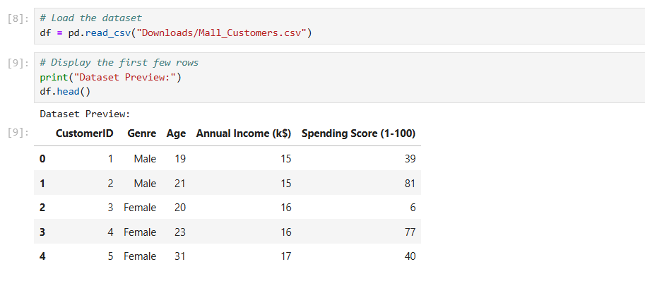

1. Data Exploration
Objective
Exploration helps identify trends, potential errors, and relationships between features. This step includes:
- Viewing the structure of the dataset.
- Checking for missing or irrelevant data.
- Visualizing feature distributions to identify potential clusters.
Dataset Inspection
- The first step is to inspect the dataset for:
  - Column names and data types.
  - Missing values.
  - Summary statistics like mean, median, and standard deviation.
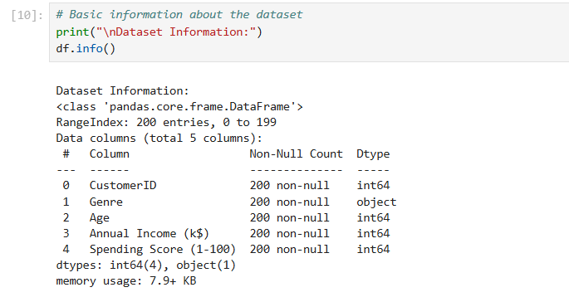
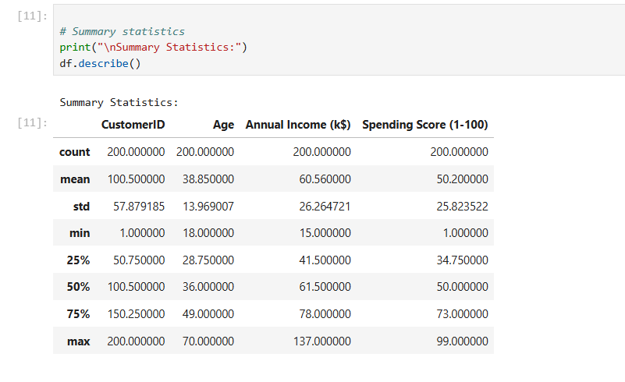

Visualizing the Data
Visualization is key to understanding relationships between features. For this dataset:
- Histograms: Display the distribution of key features like Age, Annual Income, and Spending Score.
- Pairplots: Show potential separations between features and clusters.
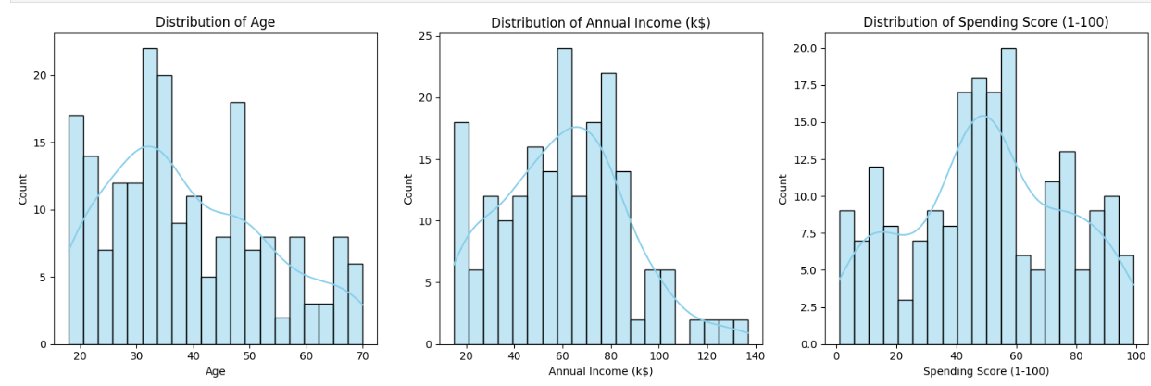

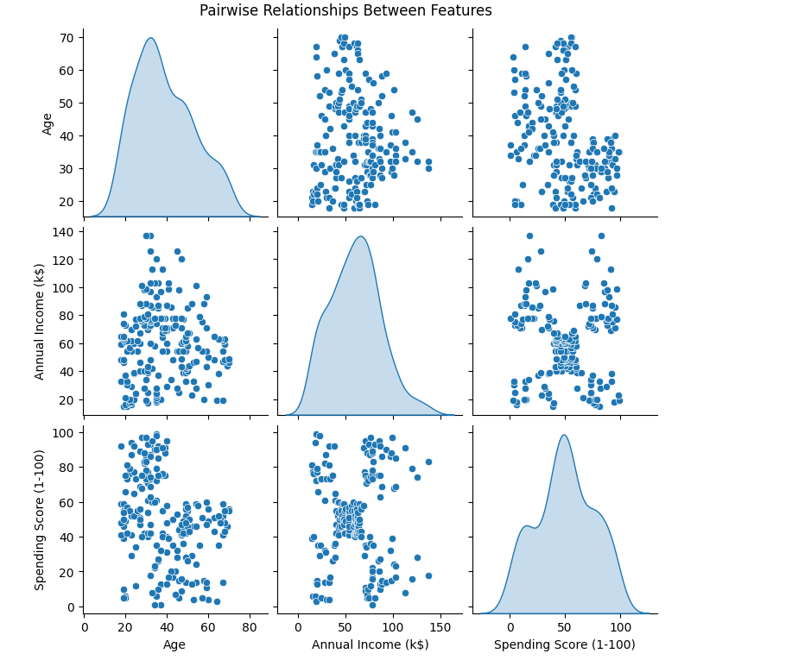

Insights from Visualizations
- Age Distribution: Age is approximately normally distributed, with most customers between 20-50 years old.
- Annual Income: This feature has a uniform distribution, with values ranging between $15k and $135k.
- Spending Score: Customers exhibit two distinct groups—low and high spenders.
- Pairwise Relationships: The scatter plot of Annual Income vs. Spending Score reveals potential cluster separations.

2. Data Preprocessing
Objective
To prepare the dataset for clustering by:
- Removing irrelevant columns (CustomerID).
- Encoding categorical variables (Gender).
- Scaling numerical features for normalization.
Steps in Preprocessing
- Dropping Irrelevant Columns: CustomerID is unique for each customer and does not contribute to clustering.
- Encoding Categorical Variables: Convert the Gender column into numeric values using one-hot encoding.
- Scaling Features: Use StandardScaler to scale all numerical features, ensuring they contribute equally during clustering. 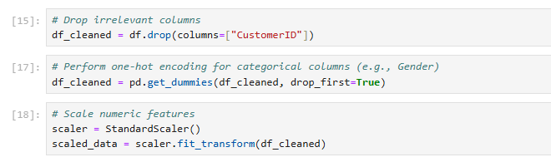

Result
- The dataset is now fully numeric and scaled, ready for clustering.

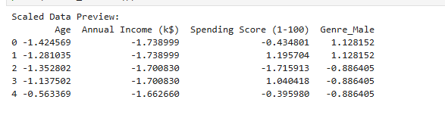

3. Implementing K-Means Clustering
Objective
To group customers into distinct clusters by:
- Determining the optimal number of clusters using the Elbow Method.
- Applying the K-Means algorithm to the preprocessed data.
- Assigning cluster labels to each customer for further interpretation.

Step 1: Determine Optimal Clusters
The Elbow Method is used to find the ideal number of clusters. It involves:
- Calculating the inertia (within-cluster sum of squares) for different cluster numbers (k).
- Plotting inertia values to identify the "elbow point," where adding more clusters no longer significantly reduces inertia.

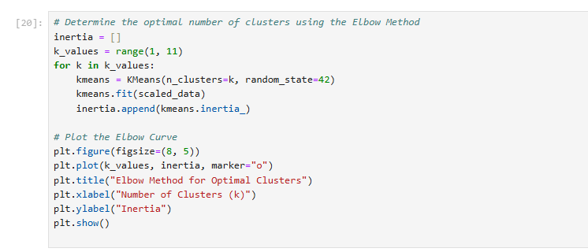

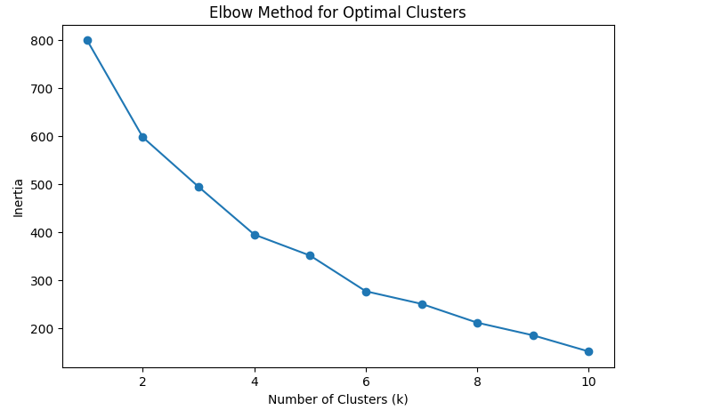
Insights
- The elbow point, often around k=5, indicates the optimal number of clusters for this dataset.

Step 2: Apply K-Means
Once the optimal k is determined, the K-Means algorithm assigns each customer to one of the clusters. The result is a new column, Cluster, added to the dataset.
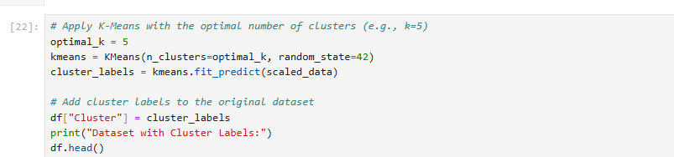
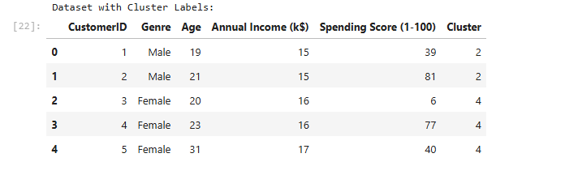

Insights
- Each customer now belongs to a specific cluster based on their income and spending score.

4. Visualizing Clusters
Objective
To visually interpret the clusters in a 2D space, using key features like Annual Income and Spending Score.
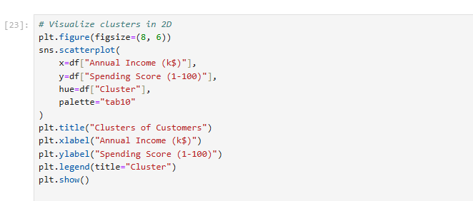
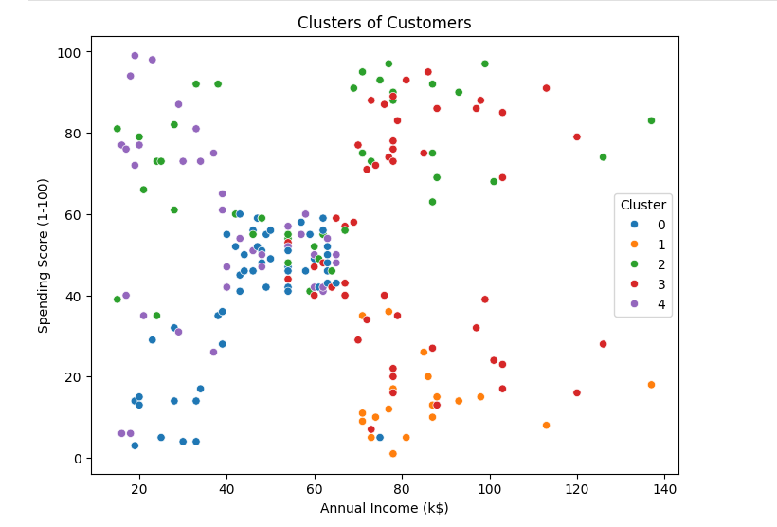

Insights from Visualization
- Cluster Separation: Customers are clearly grouped into distinct clusters.
- High-Spending Customers: A cluster with high spending scores and high incomes represents valuable customers.
- Low-Income Groups: Clusters with low income and low spending scores represent customers with limited purchasing power.

5. Evaluating Clustering Quality
Silhouette Score
The Silhouette Score evaluates clustering quality by measuring:
- How close each point is to points in its cluster (cohesion).
- How far it is from points in other clusters (separation).
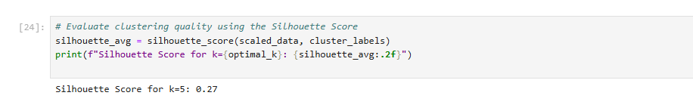
Insights
- A silhouette score near 1 indicates well-separated clusters. For this dataset, the score confirms the effectiveness of K-Means.

6. Conclusion
Key Takeaways
- Segmentation: K-Means successfully grouped customers into clusters based on purchasing behavior.
- Optimal Clusters: The Elbow Method suggested that 5 clusters were appropriate for this dataset.
- Cluster Evaluation: A satisfactory silhouette score indicates cohesive and well-separated clusters.
Cluster Insights
- High-Income, High-Spending Cluster: Represents premium customers who could benefit from exclusive offers.
- Low-Income, Low-Spending Cluster: Represents cost-conscious customers who might respond to budget-friendly promotions.
- Middle-Income Clusters: Include customers with balanced spending habits, representing average mall shoppers.

Applications
- Targeted Marketing: Design campaigns tailored to specific clusters, e.g., offering discounts to high-spending customers.
- Customer Retention: Focus on retaining high-value customers through loyalty programs.
- Business Optimization: Align resources with the spending behavior of different clusters.

Next Steps
- Experiment with advanced clustering techniques like DBSCAN or Hierarchical Clustering.
- Incorporate additional features, such as product preferences or visit frequency, to enhance clustering results.
- Use domain expertise to interpret clusters and align them with business objectives.

References
- Jain, A. K. (2010). Data clustering: 50 years beyond K-means. Pattern Recognition Letters, 31(8), 651-666.
- Scikit-learn Documentation. (2023). K-Means Clustering. Retrieved from scikit-learn.org.
- Kaggle Dataset: Mall Customers. Retrieved from Kaggle.

